**Assignment Part 3**

**1. Create a file like nano file1.txt**

Created the file name “file1.txt”



**Edit some data and then save the file**

-🡪Entered into editor mode using VIM



🡪Edited the file and saved the file using “:wq!”

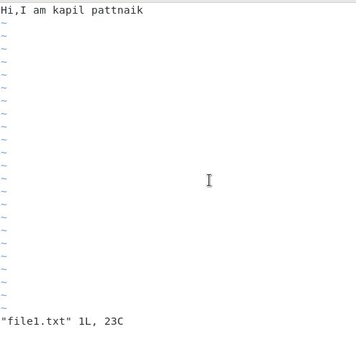

**2. Now we will copy date from file1 to new file2**

Created file2.txt and copied the contents of file1.txt to file2.txt

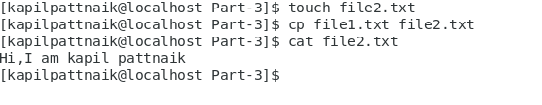

**3. Now we will move the file2.txt to new folder /home**

Logged in as Root user and moved the file.

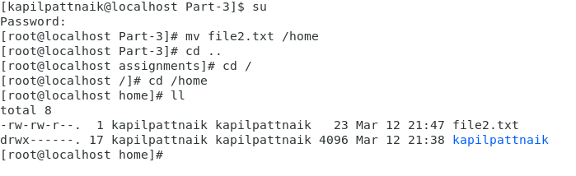

**4. Then we create a new file3.txt and file4.txt in home directory and add**

**content in it.**

Created file3.txt and file4.txt and below is the output of the echo command executed in file3.txt



Echo commadand executed in file4.txt



Both operators are often used to modify the files in Linux. The “>” is an output operator that overwrites the existing file, while “>>” is also an output operator but appends the data in an already existing file.

**5. For remove a file or directory you can use the below two commands**

Deleting directory:



Deleting file:

